Klab kids code 2018

INTRODUCTION TO HTML

HTML

HTML stands for Hypertext Markup Language, and it is the most widely used language to write Web Pages. As its name suggests, HTML is a markup language.

- Hypertext refers to the way in which Web pages (HTML documents) are linked together. When you click a link in a Web page, you are using hypertext.

- Markup Language describes how HTML works. With a markup language, you simply "mark up" a text document with tags that tell a Web browser how to structure it to display.

Originally, HTML was developed with the intent of defining the structure of documents like headings, paragraphs, lists, and so forth to facilitate the sharing of scientific information between researchers.

Creating HTML Document:-

Creating an HTML document is easy. To begin coding HTML you need only two things: a simple-text editor and a web browser. Notepad is the most basic of simple-text editors and you will probably code a fair amount of HTML with it.

You can use our HTML Online Editor to learn HTML. Here are the simple steps to create a baisc HTML document:

- Open Notepad or another text editor.
- At the top of the page type <html>.

- On the next line, indent five spaces and now add the opening header tag: <head>.
- On the next line, indent ten spaces and type <title> </title>.

- Go to the next line, indent five spaces from the margin and insert the closing header tag: </head>.
- Five spaces in from the margin on the next line, type<body>.
- Now drop down another line and type the closing tag right below its mate: </body>.
- Finally, go to the next line and type </html>.

- In the File menu, choose Save As.
- In the Save as Type option box, choose All Files.
- Name the file template.htm.
- Click Save.

You have basic HTML document now, to see some result put the following code in title and body tags.
<html>
<head>
<title>This is document title</title>
</head>
<body>
<h1>This is a heading</h1>
<p>Document description goes here.....</p>
</body>
</html>

1
Klab kids code 2018

Now you have created one HTML page and you can use a Web Browser to open this HTML file to see the result. Hope you understood that Web Pages are nothing but they are simple HTML files with some content which can be rendered using Web Browsers.

Here <html>, <head>,...<p>, <h1> etc. are called HTML tags. HTML tags are building blocks of an HTML document nd we will learn all the HTML tags in subsequent chapters. NOTE: One HTML file can have extension as .htm or .html. So you can use either of them based on your comfort.

HTML Document Structure:

An HTML document starts and ends with <html> and >/html> tags. These tags tell the browser that the entire document is composed in HTML. Inside these two tags, the document is split into two sections:

- The <head>...</head> elements, which contain information about the document such as title of the document, author of the document etc. Information inside this tag does not display outside.

- The <body>...</body> elements, which contain the real content of the document that you see on your screen.

HTML Tags and Elements:

HTML language is a markup language and we use many tags to markup text. In the above example you have seen <html>, <body> etc. are called HTML tags or HTML elements. Every tag consists of a tag name, sometimes followed by an optional list of tag attributes , all placed between opening and closing brackets (< and >). The simplest tag is nothing more than a name appropriately enclosed in brackets, such as <head> and <i>. More complicated tags contain one or more attributes , which specify or modify the behaviour of the tag. According to the HTML standard, tag and attribute names are not case-sensitive. There's no

difference in effect between <head>, <Head>, <HEAD>, or even <HeaD>; they are all equivalent.

HTML is Forgiving?

A very good quality associated with all the browsers is that they would not give any error if you have not put any HTML tag or attribute properly. They will just ignore that tag or attribute and will apply only correct tags and attributes before displaying the result.

We can not say, HTML is forgiving because this is just a markup language and required to format documents.

HTML Basic Tags:

The basic structure for all HTML documents is simple and should include the following minimum elements or tags:

- <html> - The main container for HTML pages
- <head> - The container for page header information

2

Klab kids code 2018

- <title> - The title of the page
- <body> - The main body of the page

Now we will explain each of these tags one by one. In this tutorial you will find the terms element and tag are used interchangeably.

The <html> Element:

The <html> element is the containing element for the whole HTML document. Each HTML document should have one <html> and each document should end with a closing </html> tag. Following two elements appear as direct children of an <html> element:

- <head>
- <body>

As such, start and end HTML tags enclose all the other HTML tags you use to describe the Web page.

The <head> Element:

The <head> element is just a container for all other header elements. It should be the first thing to appear after the opening <html> tag.

Each <head> element should contain a <title> element indicating the title of the document, although it may also contain any combination of the following elements, in any order:

- The <link> tag is used to link to an external file, such as a style sheet or JavaScript file. Check HTML Link tag.

- The <style> tag is used to include CSS rules inside the document. Check HTML Style tag.

- The <script> tag is used to include JAVAScript or VBScript inside the document. Check HTML Script tag.

- The <meta> tag includes information about the document such as keywords and a description, which are particularly helpful for search applications. Check HTML Meta tag.

Example:

Following is the example of head tag.

<head>
<title>wlcome to klab</title>
<meta name="Keywords" content="HTML, Web Pages" /> <meta name="description" content="HTML Basic Tags" /> <base href="http://www.klab.rw" />

<link rel="stylesheet" type="text/css" href="tp.css" /> <script type="text/javascript">

3

Klab kids code 2018

_uacct = "UA-232293";
urchinTracker();
</script>
</head>

The <title> Element:

You should specify a title for every page that you write inside the <title> element. This element is a child of the <head> element). It is used in several ways:

- It displays at the very top of a browser window.

- It is used as the default name for a bookmark in browsers such as IE and Netscape.

- It is used by search engines that use its content to help index pages.

Therefore it is important to use a title that really describes the content of your site. The <title> element should contain only the text for the title and it may not contain any other elements.

Example:
Here is the example of using title tag.

<head>
<title>HTML Basic tags</title>
</head>

The <body> element appears after the <head> element and contains the part of the Web page that you actually see in the main browser window, which is sometimes referred to as body content.

A <body> element may contain anything from a couple of paragraphs under a heading to more complicated layouts containing forms and tables.

Most of what you will be learning in this and the following five chapters will be written between the opening <body> tag and closing </body> tag.

Example:
Here is the example of using body tag.

<body>
<p>This is a paragraph tag.</p>
</body>

HTML Meta Tags

Meta tags allow you to provide metadata about your HTML pages. This can be very useful

for search engines and can assist the "findability" of the information on your website.

4

Klab kids code 2018

What is Metadata?

Metadata is information about, or that describes, other data or information.

If we relate this to a web page, if you think about it for a moment, you could probably come

up with a lot more information about a web page than what you're actually displaying to the

reader.

For example, there could be a number of keywords that are related to the page. You could

probably give the page a description. The page also has an author - right? All these could be

examples of metadata.

Metadata on the Web

Metadata is a very important part of the web. It can assist search engines in finding the best

match when a user performs a search. Search engines will often look at any metadata attached

to a page - especially keywords - and rank it higher than another page with less relevant

metadata, or with no metadata at all.

Adding Meta Tags to Your Documents

You can add metadata to your web pages by placing <meta> tags between the <head></head> tags. The can include the following attributes:

Attribute Description

Name

content

scheme

http-equiv

Name for the property. Can be anything. Examples include, keywords, description, author, revised, generator etc.

Specifies the property's value.

Specifies a scheme to use to interpret the property's value (as declared in the content attribute).

Used for http response message headers. For example http-equiv can be used to refresh the page or to set a cookie. Values include content-type, expires, refresh and set-cookie.

Example HTML Code

Keywords:

<meta name="keywords" content="HTML, meta tags, metadata">

5

Klab kids code 2018

Description:

<meta name="description" content="Contains info about meta tags">

Revision date (last time the document was updated):

<meta name="revised" content="Quackit, 6/12/2012">

Refresh the page every 10 seconds:

<meta http-equiv="refresh" content="10">

The above examples are some of the more common uses for the meta tag.

Meta Tag Examples:

Let's see few important usages of Meta Tags.

Specifying Keywords

We specify keywords which will be used by the search engine to search a web page. So using following tag you can specify important keywords related to your page.

<head>
<meta name="keywords" content="HTML, meta tags, metadata" /> </head>

Document Description

This is again important information and many search engine use this information as well while searching a web page. So you should give an appropriate description of the page.

<head>
<meta name="description" content="Learn about Meta Tags." /> </head>

Document Revision date:
This information tells about last time the document was updated.

<head>

<meta name="revised" content="Tutorialspoint, 6/12/2006" /> </head>

Document Refreshing

You can specify a duration after which your web page will keep refreshing. If you want your page keep refreshing after every 10 seconds then use the following syntax.

6
Klab kids code 2018

<head>
<meta http-equiv="refresh" content="10" />
</head>

Page Redirection

You can specify a page redirection using Meta Tag. Following is an example of redirecting current page to another page. You can specify a duration after which page will be redirected.

<head>
<meta http-equiv="refresh"
content="10; url=http://www.rtuc.ac.rw" />
</head>

N.B:-If you don't provide a duration then page will be redirected immediately.

Setting Author Name

You can set an author name in a web page using Meta Tag. See an example below:

<head>
<meta name="author" content="Kundan Kumar" /> </head>

If you do not include the expiration date and time, the cookie is considered a session cookie and will be deleted when the user exits the browser.

HTML Attributes:

Attributes are another important part of HTML markup. An attribute is used to define the characteristics of an element and is placed inside the element's opening tag. All attributes are made up of two parts: a name and a value:

- The name is the property you want to set. For example, the <font> element in the example carries an attribute whose name is face, which you can use to indicate which typeface you want the text to appear in.

- The value is what you want the value of the property to be. The first example was supposed to use the Arial typeface, so the value of the face attribute is Arial.

The value of the attribute should be put in double quotation marks, and is separated from the name by the equals sign. You can see that a color for the text has been specified as well as the typeface in this <font> element: <font face="arial" color="#CC0000">

HTML Tags:

Create Headings - The <hn> Elements:

7
Klab kids code 2018

Any documents starts with a heading. You use different sizes for your headings. HTML also have six levels of headings, which use the elements <h1>, <h2>, <h3>, <h4>, <h5>, and <h6>. While displaying any heading, browser adds one line before and after that heading.

Example:

<h1>This is heading 1</h1>

<h2>This is heading 2</h2>
<h3>This is heading 3</h3>

<h4>This is heading 4</h4>
<h5>This is heading 5</h5>

<h6>This is heading 6</h6>
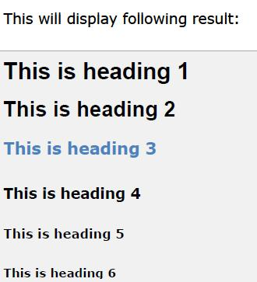

Create Paragraph - The <p> Element:

The <p> element offers a way to structure your text. Each paragraph of text should go in between an opening <p> and closing </p> tag as shown below in the example:

Example:

<p>Here is a paragraph of text.</p>
<p>Here is a second paragraph of text.</p>
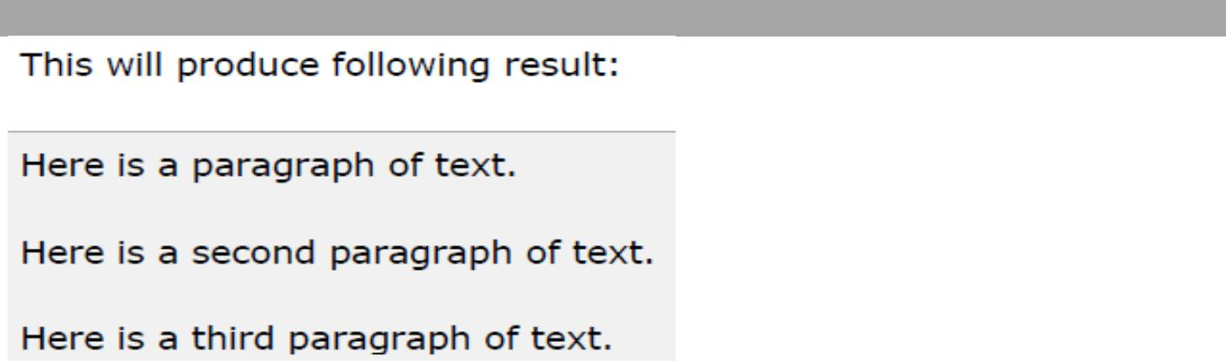
<p>Here is a third paragraph of text.</p>

8
Klab kids code 2018

You can use align attribute to align your paragraphs. <p align="left">This is left aligned.</p> <p align="center">This is center aligned.</p>

<p align="right">This is right aligned.</p> <p align="justify">This is jutified. This works when you have multiple lines in your paragraph and you want to justfy all the lines so that they can look more nice.</p>
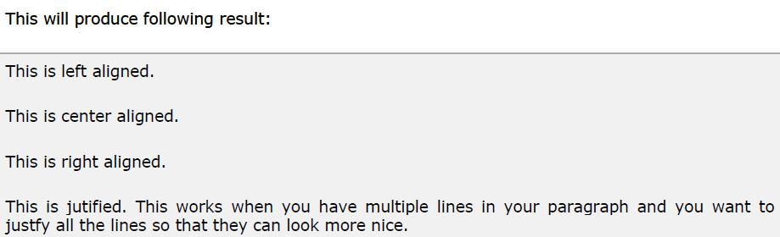

Create Line Breaks - The <br /> Element:

Whenever you use the <br /> element, anything following it starts on the next line. This tag is an example of an empty element, where you do not need opening and closing tags, as there is nothing to go in between them.

Note: The <br /> element has a space between the characters br and the forward slash. If you omit this space, older browsers will have trouble rendering the line break, while if you miss the forward slash character and just use <br> it is not valid XHTML
Example: Hello<br />

You come most carefully upon your hour.<br /> Thanks<br />

Mahnaz

9
Klab kids code 2018
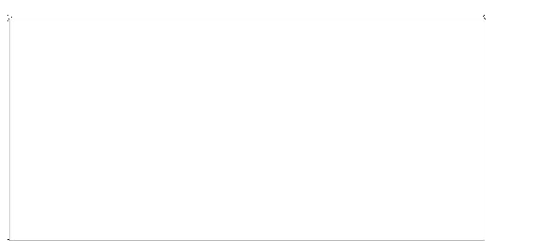
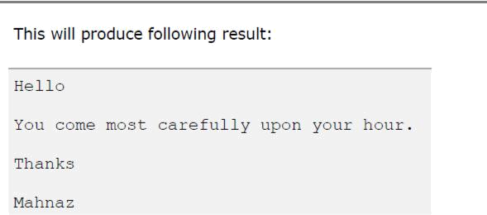

Centring Content - The <center> Element:

You can use <center> tag to put any content in the center of the page or any table cell.
Example:

<p>This is not in the center.</p>

<center>
<p>This is in the center.</p>
</center>
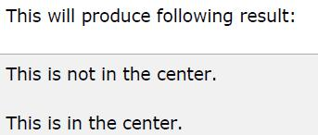

Nonbreaking Spaces:

Suppose you were to use the phrase "12 Angry Men." Here you would not want a browser to split the "12" and "Angry" across two lines:

10

Klab kids code 2018
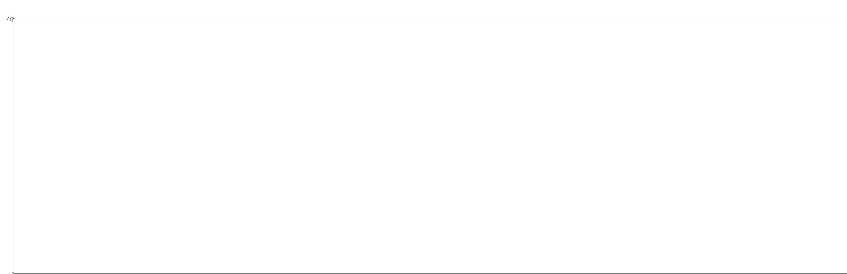
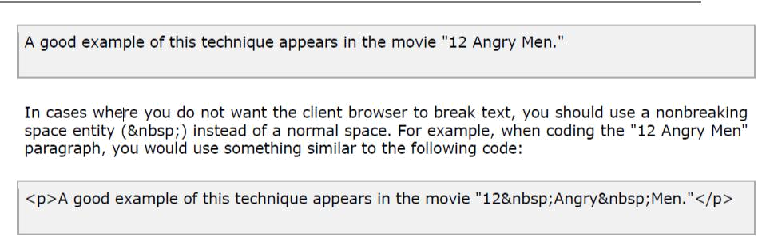

Horizontal Rules - The <hr /> Element:

Horizontal rules are used to visually break up sections of a document. The <hr> tag creates a line from the current position in the document to the right margin and breaks the line accordingly.
For example you may want to give a line between two paragraphs as follows:
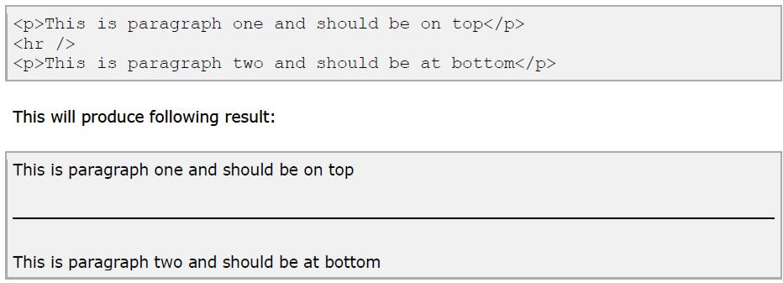

Again <hr /> tag is an example of an empty element, where you do not need opening and closing tags, as there is nothing to go in between them.

Note: The <hr /> element has a space between the characters br and the forward slash. If you omit this space, older browsers will have trouble rendering the line break, while if you miss the forward slash character and just use <hr> it is not valid XHTML

Presentational Tags:-

If you use a word processor, you are familiar with the ability to make text bold, italicized, or underlined; these are just three of the ten options available to indicate how text can appear in HTML.

11
Klab kids code 2018

Bold Text - The <b> Element:
Anything that appears in a <b>...</b> element is displayed in bold, like the word bold here:
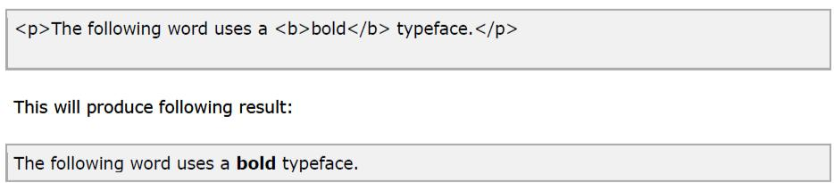

Italic Text - The <i> Element:

Anything that appears in a <i>...</i> element is displayed in italicized, like the word italicized here:
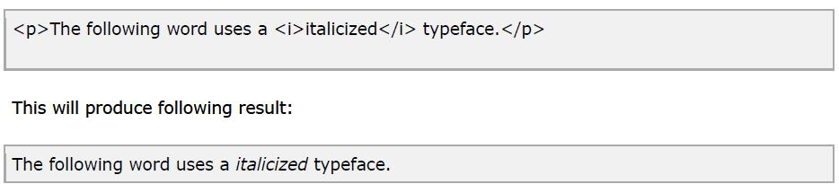

Underlined Text - The <u> Element:

Anything that appears in a <u>...</u> element is displayed with underline, like the word underlined here:
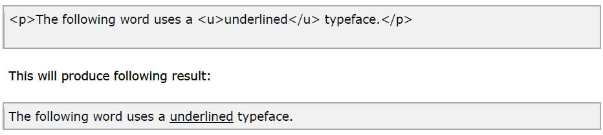

Strike Text - The <strike> Element:

Anything that appears in a <strike>...</strike> element is displayed with strikethrough, which is a thin line through the text:

12
Klab kids code 2018

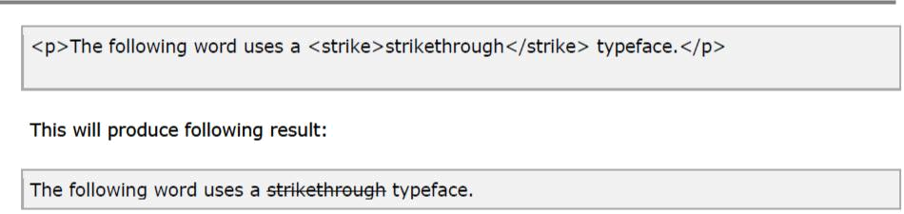

Superscript Text - The <sup> Element:

The content of a <sup> element is written in superscript; the font size used is the same size as the characters surrounding it but is displayed half a character.s height above the other characters.
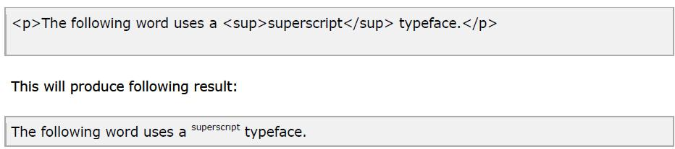

Subscript Text - The <sub> Element:

The content of a <sub> element is written in subscript; the font size used is the same as the characters surrounding it, but is displayed half a character.s height beneath the other characters.
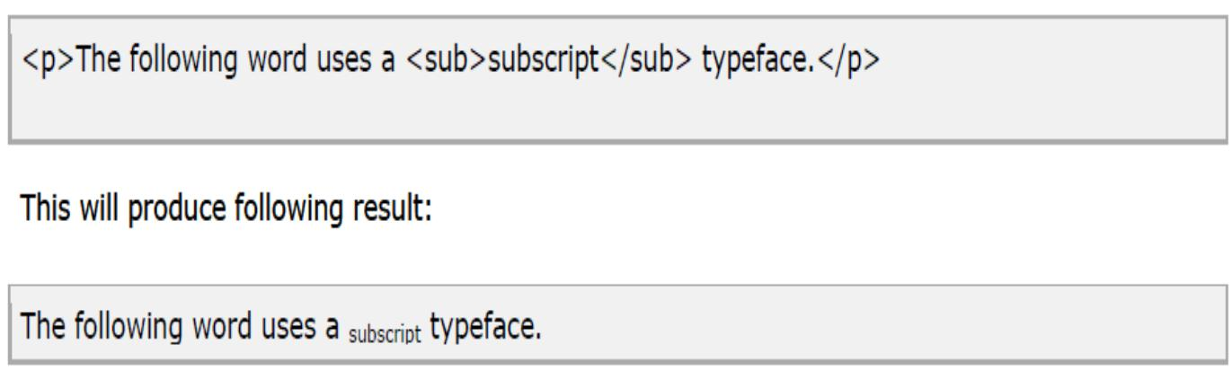

Larger Text - The <big> Element:

13
Klab kids code 2018

The content of the <big> element is displayed one font size larger than the rest of the text surrounding it.
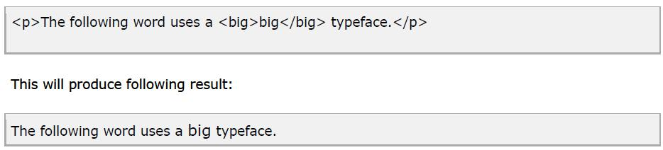

Smaller Text - The <small> Element:

The content of the <small> element is displayed one font size smaller than the rest of the text surrounding it.
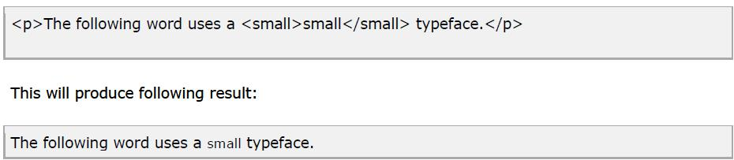

Grouping - The <div> and <span> Elements :

The <div> and <span> elements allow you to group together several elements to create sections or subsections of a page.

For example, you might want to put all of the footnotes on a page within a <div> element to indicate that all of the elements within that <div> element relate to the footnotes. You might then attach a style to this <div> element so that they appear using a special set of style rules. The <div> element is used to group block-level elements together:

14
Klab kids code 2018
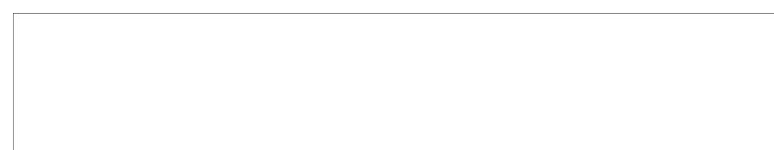
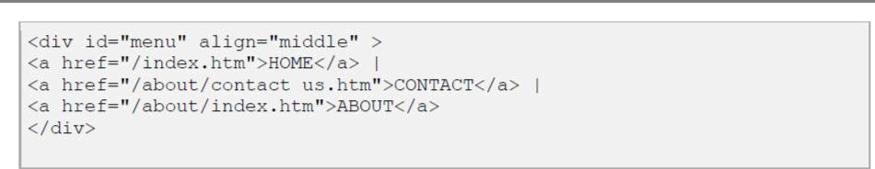
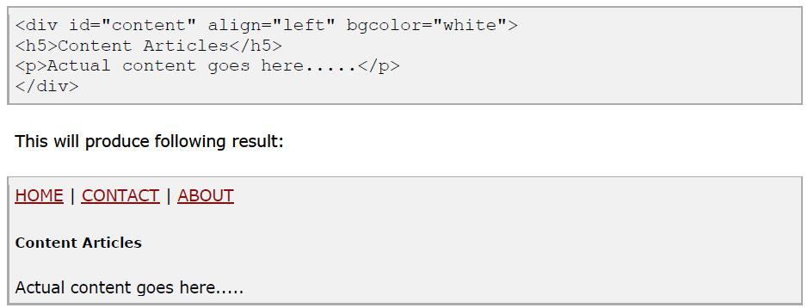

The <span> element, on the other hand, can be used to group inline elements only. So, if you had a part of a sentence or paragraph you wanted to group together you could use the <span> element.
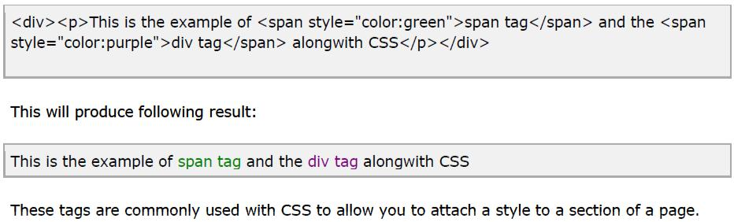

HTML Comments:-

15
Klab kids code 2018

Comments are piece of code which is ignored by any web browser. It is good practice to comment your code, especially in complex documents, to indicate sections of a document, and any other notes to anyone looking at the code. Comments help you and others understand your code.

HTML Comment lines are indicated by the special beginning tag <!-- and ending tag --> placed at the beginning and end of EVERY line to be treated as a comment.

Comments do not nest, and the double-dash sequence "--" may not appear inside a comment except as part of the closing --> tag. You must also make sure that there are no spaces in the start-of-comment string.

For example:

Given line is a valid comment in HTML <!-- This
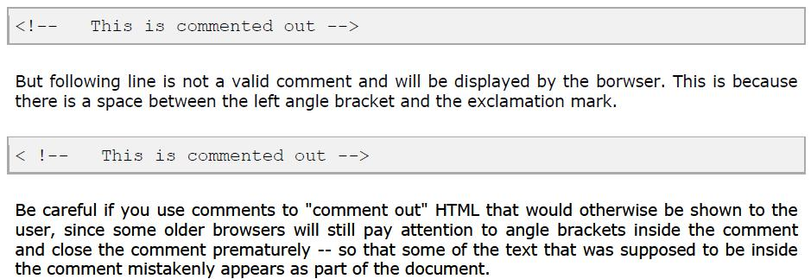

Multiline Comments:

You have seen how to comment a single line in HTML. You can comment multiple lines by the special beginning tag <!-- and ending tag --> placed before the first line and end of the lastline to be treated as a comment.
For example:
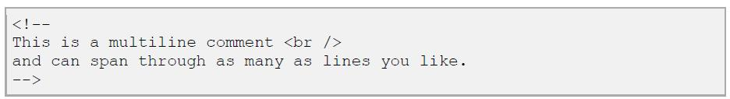

HTML Fonts :-

Font face and color depends entirely on the computer and browser that is being used to view your page. But the <font> tag is used to add style, size, and color to the text on your site. You can use a <basefont> tag to set all of your text to the same size, face, and color.

16
Klab kids code 2018

The font tag is having three attributes called size, color, and face to customize your fonts.

To change any of the font attributes at any time within your page, simply use the <font> tag. The text that follows will remain changed until you close with the </font> tag. You can change any or all of the font attributes at the one time, by including all the required changes within the one <font> tag.

N.B: The font and basefont tags are deprecated and it is supposed to be removed in a future version of HTML. So it should not be used. Its is suggested to use css styles to manipulate your font.

Font Size:

You can set the size of your

You can set the size of your font with size attribute. The range of accepted values is from 1(smallest) to 7(largest). The default size of a font is 3. Example:
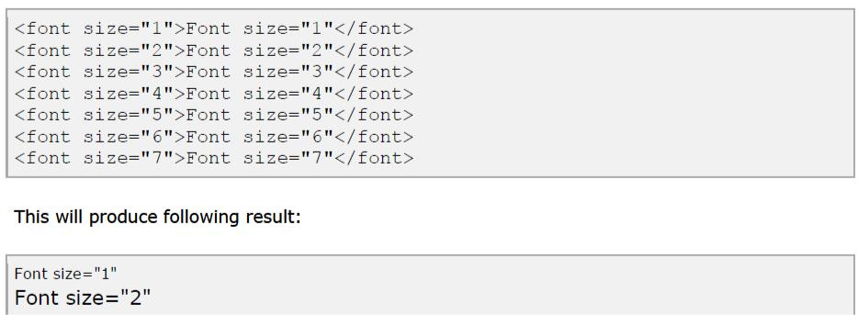

17
Klab kids code 2018
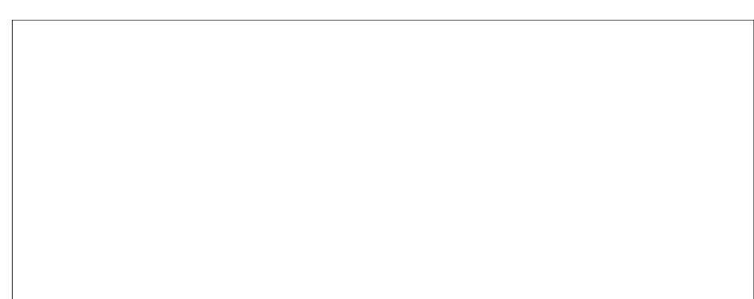
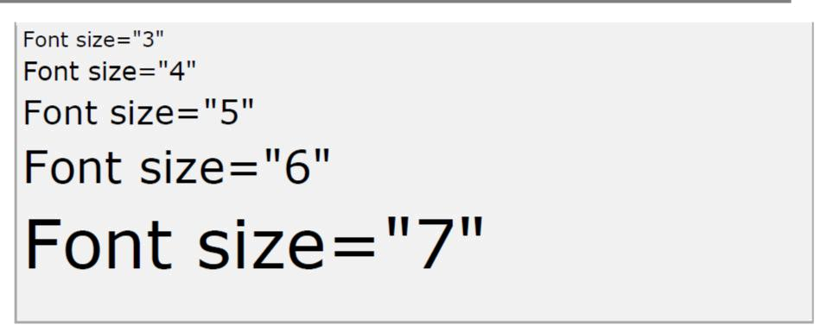

Font Face:

You can set any font you like using face attribute but be aware that if the user viewing the page doesn't have the font installed, they will not be able to see it. Instead they will default to Times New Roman of your font with size attribute. See below few examples on using different font face

Example:
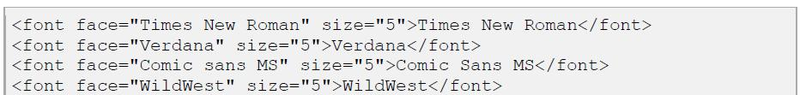

18
Klab kids code 2018
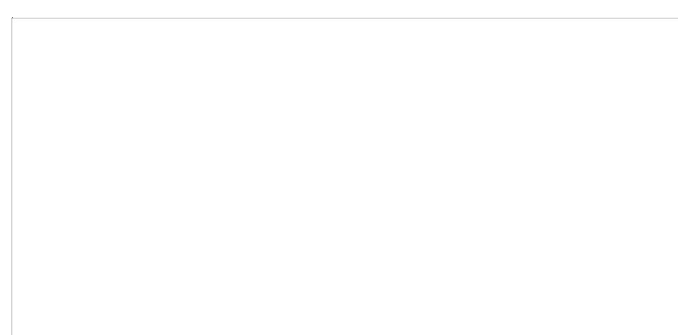
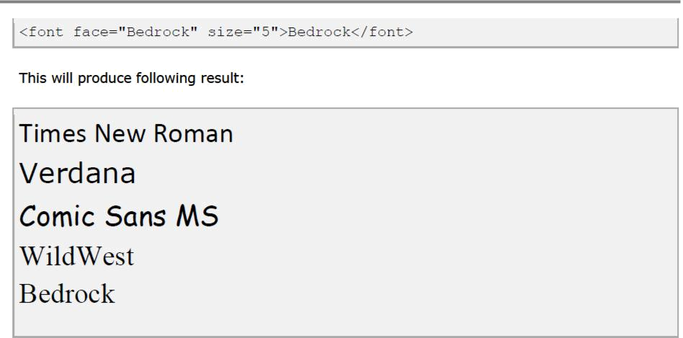

Font Color:

You can set any font color you like using color attribute. You can specify the color that you want by either the color name or hexadecimal code for that color. Check a complete list of HTML Color Name with Codes.

Example:
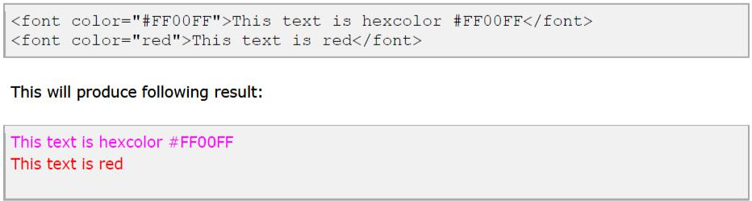

HTML Images:-

Images are very important to beautify as well as to depicts many concepts on your web page. Its is true that one single image is worth than thuasands of words. So as a Web Developer you should have clear understanding on how to use images in your web pages.

Insert Image - The <img> Element:

You will insert any image in your web page by using <img> tag. Following is the simple syntax to use this tag.

19
Klab kids code 2018
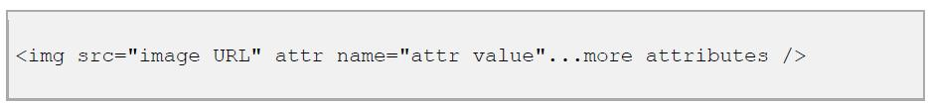

Image Attributes:
Following are most frequently used attributes for <img> tag.
- width: sets width of the image. This will have a value like 10 or 20%etc.

- height: sets height of the image. This will have a value like 10 or 20% etc.

- border: sets a border around the image. This will have a value like 1 or 2 etc.

- src: specifies URL of the image file.

- alt: this is an alternate text which will be displayed if image is missing.

- align: this sets horizontal alignment of the image and takes value either left, right or center.

- valign: this sets vertical alignment of the image and takes value either top, bottom or center.

- hspace: horizontal space around the image. This will have a value like 10 or 20%etc.

- vspace: vertical space around the image. This will have a value like 10 or 20%etc.

- name: name of the image with in the document.

- id: id of the image with in the document.

- style: this will be used if you are using CSS.

- title: specifies a text title. The browser, perhaps flashing the title when the mouse passes over the link.

A Simple Example:

<img src="html.gif" alt="HTML Tutorial" >
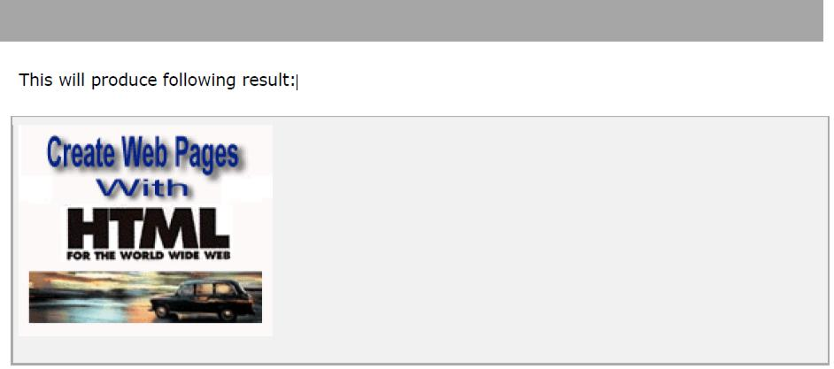

Image Attributes - width, height, title, border and align:
Now let us try to set some more attributes:

<img src=" html.gif" alt="HTML Tutorial" width="100" height="100" border="2" align="right" title="HTML Tutorial" />

20
Klab kids code 2018

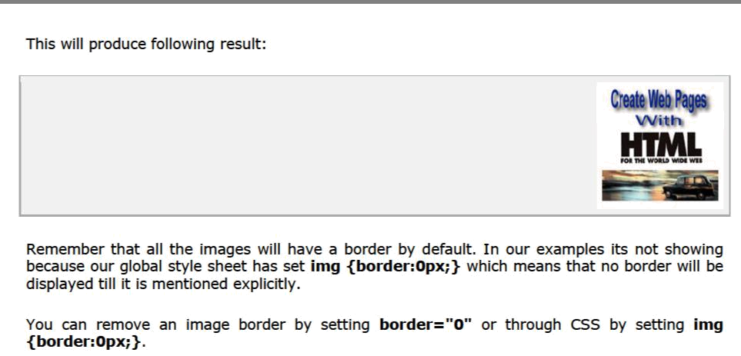

Wrapping text around images:

Example 1:

<p>This is the first paragraph that appears above the paragraph with the image!</p> <p><img src=" html.gif" width="75" height="75" alt="HTML Tutorial" align="right"> The image will appear along the right hand side of the paragraph. As you can see this is very nice for adding a little eye candy that relates to the specified paragraph.</p> <p>The left and right image-alignment values tell the browser to place an image against the left or right margin, respectively, of the current text flow. The browser then renders subsequent document content in the remaining portion of the flow adjacent to the image. The net result is that the document content following the image gets wrapped around the image. </p>
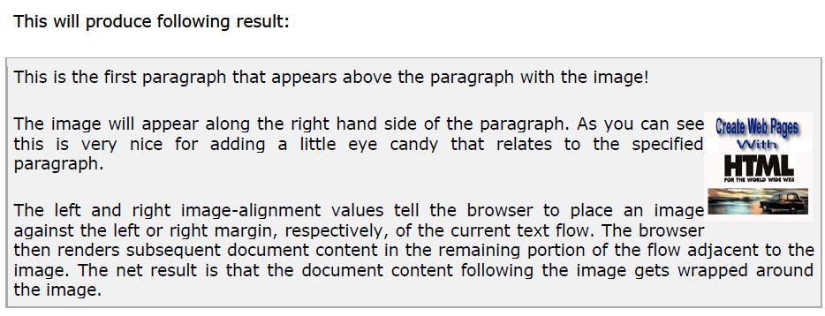

21
Klab kids code 2018

Example 2:

You can use vspace or hspace attributes if you want to keep some distance between text and image. Let us revise above example:

<p>This is the first paragraph that appears above the paragraph with the image!</p> <p><img src=" html.gif" vspace="10" hspace="15" width="75" height="75" alt="HTML Tutorial" align="right"> The image will appear along the right hand side of the paragraph. As you can see this is very nice for adding a little eye candy that relates to the specified paragraph.</p> <p>The left and right image-alignment values tell the browser to place an image against the left or right margin, respectively, of the current text flow. The browser then renders subsequent document content in the remaining portion of the flow adjacent to the image. The net result is that the document content following the image gets wrapped around the image. </p>
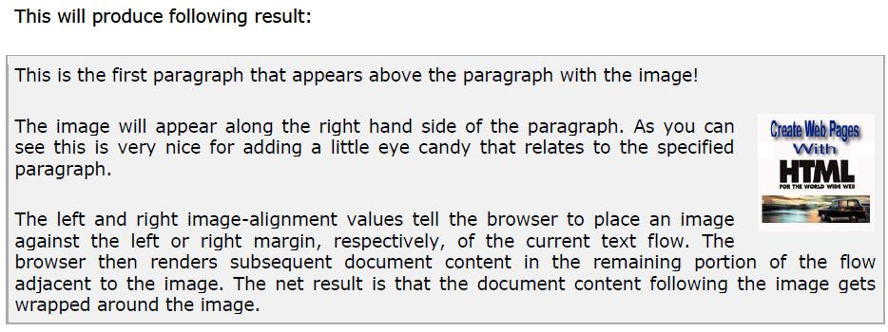

HTML Text Links:-

Web pages can contain links that take you directly to other pages and even specific parts of a given page. These links are known as hyperlinks.

Hyperlinks allow visitors to navigate between Web sites by clicking on words, phrases, and images. Thus you can create hyperlinks using text or images available on your any web page. In this tutorial you will learn how to create text links between the different pages of your site, links within pages of your sites, and how to link to other sites ( or external sites). If you want to know more about URL then check Understanding URL Tutorial.

Linking Documents - The <a> Element:

A link is specified using the <a> element. This element is called anchor tag as well. Anything between the opening <a> tag and the closing </a> tag becomes part of the link and a user can click that part to reach to the linked document. Following is the simple syntax to use this tag.

22
Klab kids code 2018
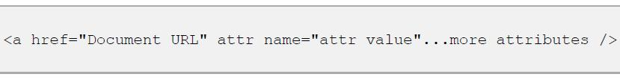

Anchor Attributes:
Following are most frequently used attributes for <a> tag.

- href: specifies the URL of the target of a hyperlink. Its value is any valid document URL, absolute or relative, including a fragment identifier or a JavaScript code fragment.

- target: specify where to display the contents of a selected hyperlink. If set to "_blank" then a new window will be opened to display the loaded page, if set to "_top" or "_parent" then same window will be used to display the loaded document, if set to "_self" then loads the new page in current window. By default its "_self".

- name & id: attributes places a label within a document. When that label is used in a link to that document, it is the equivalent of telling the browser to goto that label.

- title: attribute lets you specify a title for the document to which you are linking. The value of the attribute is any string, enclosed in quotation marks. The browser might use it when displaying the link, perhaps flashing the title when the mouse passes over the link.

A Simple Example:

<a href="index.html" target="_blank" >Home</a> |

<a href="Aboutus.html" target="_self" >About Us</a> | <a href="Contactus.html target="_top" >Contact Us</a>

This will produce following result, Click and come back to proceed with rest of the tutorial:

Home | About Us | Contact Us

Create Download Links:

You can create text link to make your PDF, or DOC or ZIP files downloadable. This is very simple, you just need to give complete URL of the downloadable file as follows:
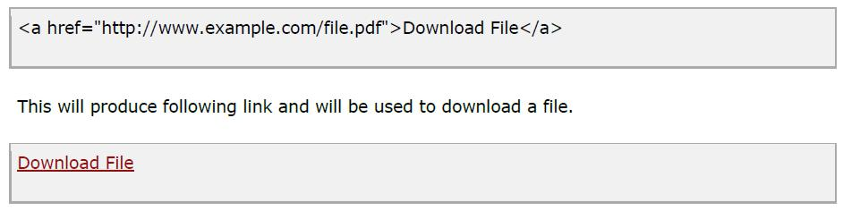

23
Klab kids code 2018

List:

Basically there are two types of List in HTML as

- Ordered list, and

- Unordered list.

Ordered List: An ordered list starts with the <ol> tag. Each list item starts with the <li> tag.

Example:

<ol >

<li>Banana</li>

<li>Apple</li>

<li>Avocado</li>

<li>Mango</li>

</ol>

The Type Attribute of Ordered HTML List

Type | Description
type="1" | The list items will be numbered with numbers (default)
type="A" | The list items will be numbered with uppercase letters
type="a" | The list items will be numbered with lowercase letters
type="I" | The list items will be numbered with uppercase roman numbers
type="i" | The list items will be numbered with lowercase roman numbers
Example

<ol type="A">

24

Klab kids code 2018

<li>bazimya</li>

<li>maraika</li>

<li>Peace</li>

<li>jamari</li>

</ol>

OUTPUT

- bazimya

- maraika
- peace

- jamari

The Start Attribute of Ordered HTML List

<ol type="A" start="3">

<li>Banana</li>

<li>Apple</li>

<li>Avocado</li>

<li>Mango</li>

</ol>

OUTPUT

- Banana
- Apple

- Avocado
- Mango

Unordered List

• An unordered list starts with the <ul> tag.

25

Klab kids code 2018

- Each list item starts with the <li> tag.
- The list items will be marked with dark circle bullets by default

Example

<ul>
<li>Banana</a></li>

<li>Apple</li>
<li>Avocado</li>

<li>Mango</li>
</ul>
OUTPUT

- Banana

- Apple
- Avocado
- Mango

The Type Attribute of Ordered HTML List

Value | Description
disc | Sets the list item marker to a bullet (default)
circle | Sets the list item marker to a circle
square | Sets the list item marker to a square
none | The list items will not be marked

Example

<ul type="circle">

<li>Banana</a></li>
<li>Apple</li>

<li>Avocado</li>

<li>Mango</li>

</ul>

OUTPUT

- Banana
o Apple

o Avocado o Mango

HTML Forms

HTML enables us to create forms. This is where our websites can become more than just a nice advertising brochure. Forms allow us to build more dynamic websites that allow our users to interact with it.

26

Klab kids code 2018

An HTML form is made up of any number of form elements. These elements enable the user to do things such as enter information or make a selection from a preset options.

In HTML, a form is defined using the <form></form> tags. The actual form elements are defined between these two tags.

The <input> Tag

This is the most commonly used tag within HTML forms. It allows you to specify various types of user input fields such as text, radio buttons, checkboxes etc.

Text

Text fields are used for when you want the user to type text or numbers into the form.

<input type="text" />

Radio Buttons

Radio buttons are used for when you want the user to select one option from a pre-determined set of options.

<input type="radio" name="lunch" value="pasta" /> Pasta<br />

<input type="radio" name="lunch" value="rissotto" /> Rissotto

Checkboxes

Checkboxes are similar to radio buttons, but enable the user to make multiple selections..

<input type="checkbox" name="technology" value="HTML" /> I know HTML<br /> <input type="checkbox" name="technology" value="CSS" /> I know CSS

Select Lists

A select list is a dropdown list with options. This allows the user to select one option from a list of pre-defined options.

The select list is created using the <select> element in conjunction with the <option> element.

27

Klab kids code 2018

<select>

<option value ="sydney">Sydney</option> <option value ="melbourne">Melbourne</option> <option value ="cromwell">Cromwell</option> <option value ="queenstown">Queenstown</option>

</select>
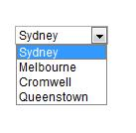

Submit

The submit button allows the user to actually submit the form.

<input type="submit" />
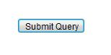

Form Action

Usually when a user submits the form, you need the system to do something with the data. This is where the action page comes in. The action page is the page that the form is submitted to. This page could contain advanced scripts or programming that inserts the form data into a database or emails an administrator etc.

Creating an action page is outside the scope of this tutorial. In any case, many web hosts provide scripts that can be used for action page functionality, such as emailing the webmaster whenever the form has been completed. For now, we will simply look at how to submit the form to the action page.

You nominate an action page with the action attribute.

<form action="/html/tags/html_form_tag_action.cfm" method="get">

First name:

28

Klab kids code 2018

<input type="text" name="first_name" value="" maxlength="100" />

<br />

Last name:

<input type="text" name="last_name" value="" maxlength="100" /> <input type="submit" value="Submit" /> </form>
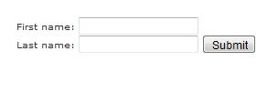

Oh, one last thing. You may have noticed the above example uses a method attribute. This attribute specifies the HTTP method to use when the form is submitted.

Possible values are:

- get (the form data is appended to the URL when submitted)

- post (the form data is not appended to the URL)

Providing this attribute is optional. If you don't provide it, the method will be post.

HTML Comments

Before we go any further, I'd like to introduce the concept of comments. Although comments are optional, they can assist you greatly.

Comments are a part of the HTML code and is used to explain the code. The main thing to remember is that HTML comments are not visible to your website visitors. This can be helpful for other HTML coders when trying to interpret someone elses code. It can also be useful for yourself if you have to revisit your code in many months, or even years time.

Comments aren't displayed in the browser - they are simply there for the programmer's benefit.

You write comments like this:

<!-- Write your comment here -->

Comments always start with <!-- and end with -->. This tells the browser when a comment begins and ends.

Example HTML Code:

29

Klab kids code 2018

<!-- Display a happy image -->

<img src="http://www.quackit.com/pix/smile.gif" style="max-width:100%" alt="Smile" />

As you can see, the comment is invisible to the user viewing the page in the browser. It is there, simply for the HTML coder's benefit.

Multiline comments (i.e. comments that span across multiple lines), use the same syntax as single line comments. You begin the comment with <!-- and end with -->. Whether the comment spans one line or ten, you still use the same opening and closing tags.

Well, we have now finished the first part of this tutorial. We have covered a lot, and by now, you have learned enough to build a website.

If you'd like to learn some of the more advanced HTML techniques, such as, how to create tables, frames, forms etc, please continue!

HTML Tables

In HTML, the original purpose of tables was to present tabular data. Although they are still used for this purpose today, many web designers tended to use tables for advanced layouts. This is probably due to the restrictions that HTML has on layout capabilities - it wasn't really designed as a layout language.

Anyway, whether you use tables for presenting tabular data, or for page layouts, you will use the same HTML tags.

Basic table tags

In HTML, you create tables using the <table> tag, in conjunction with the <tr> and <td> tags. Although there are other tags for creating tables, these are the basics for creating a table in HTML.

<table border="1">

<tr>

<td>Table cell 1</td><td>Table cell 2</td>

</tr>

</table>
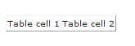

30

Klab kids code 2018

You'll notice that we added a border attribute to the table tag. This particular attribute allows us to specify how thick the border will be. If we don't want a border we can specify 0 (zero).

You can also add attributes to other table elements, such as the td tag, as you will see below.

Table Width

Widths can be specified using the CSS width property, in either pixels or percentages. Specifying the width in pixels allows you to specify an exact width. Percentages allows the table to "grow" or "shrink" depending on what else is on the page and how wide the browser is.

<table border="1" style="width:90%;">

<tr>

<td>Table cell 1</td><td>Table cell 2</td>

</tr>

</table>

Table Headers

Many tables, particularly those with tabular data, have a header row or column. In HTML, you can use the th tag.

Most browsers display table headers in bold and center-aligned.

<table border="1" style="width:90%;">

<tr>

<th>Table header</th><th>Table header</th>

</tr>

<tr>

<td>Table cell 1</td><td>Table cell 2</td>

</tr>

31

Klab kids code 2018

</table>

Colspan

You can use the colspan attribute to make a cell span multiple columns.

<table border="1">

<tr>

<th colspan="2">Table header</th>

</tr>

<tr>

<td style="width:20%;">Table cell 1</td><td>Table cell 2</td>

</tr>

</table>

Rowspan

Rowspan is for rows just what colspan is for columns (rowspan allows a cell to span multiple rows).

<table border="1" style="width:80%;">

<tr>

<th rowspan="2" style="width:20%;">Table header</th>

<td>Table cell 1

</tr>

32
Klab kids code 2018

<tr>

<td>Table cell 2</td>

</tr>

</table>

Color

You can apply color to your table using CSS. Actually, you can apply any applicable CSS property to your table - not just colors. For example, you can use CSS to apply width, padding, margin, etc

<table border="1" style="width:90%;background-color:greenyellow;color:green;">

<tr>

<th style="text-align:center;color:black;" colspan="2">Table header</th>

</tr>

<tr>

<td>Table cell 1</td><td>Table cell 2</td>

</tr>

</table>

HTML Layouts

You may have noticed that many websites have multiple columns in their layout - they are formatted like a magazine or newspaper. Many websites achieved this HTML layout using tables.

HTML layout with tables

33
Klab kids code 2018

Tables have been a popular method for achieving advanced layouts in HTML. Generally, this involves putting the whole web page inside a big table. This table has a different column or row for each main section.

For example, the following HTML layout example is achieved using a table with 3 rows and 2 columns - but the header and footer column spans both columns (using the colspan attribute):

<table style="width:100%;border:0;" border="0">

<tr>

<td colspan="2" style="background-color:yellow;">Header</td>

</tr>

<tr>

<td style="background-color:orange;width:30%;text-align:top;">Left menu<br />Item 1<br />Item 2<br />Item 3...</td>

<td style="background-color:#eeeeee;height:200px;width:70%;text-align:top;">Main body</td>

</tr>

<tr>

<td colspan="2" style="background-color:yellow;">Footer</td>

</tr>

</table>

34

Klab kids code 2018
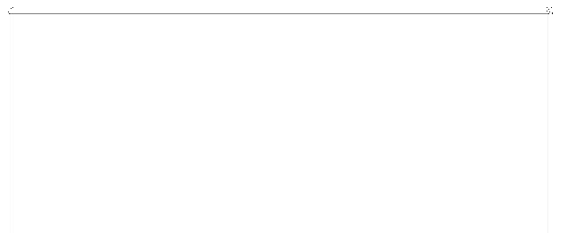
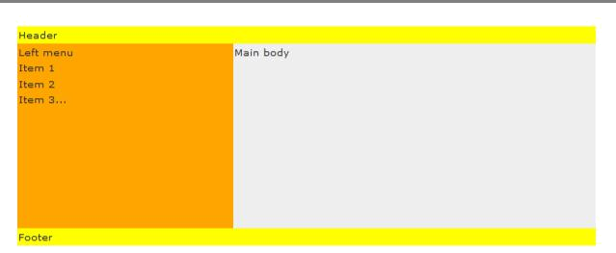

HTML iFrames

In HTML, iframes defines an inline frame. An inline frame enables you present another HTML document within the same window. The W3C refers to iframes as a nested browsing context. In other words, you can browse an HTML document that is nested inside another. Typically the iframe takes up a small portion of the document, but you could make it any size you like.

Inline frames are often used in advertising. Many advertisers and advertising networks use iframes to display their ad within a publisher's website. Benefits of using iframes for advertising include more control for the advertiser over how the ad is displayed, as well as enhanced performance monitoring.

Creating an iframe

To create an iframe, you use the <iframe> tag. The src attribute provides the URL of the external document to use within the iframe. The seamless attribute determines that it should blend seamlessly into the containing document, so that it actually appears to be part of the containing document. Also, you can set the width and height using the width and height attributes.

Here's an example:

<iframe src="/html_5/tags/html_iframe_tag_example.cfm" width="150" height="150" seamless></iframe>

35

Klab kids code 2018

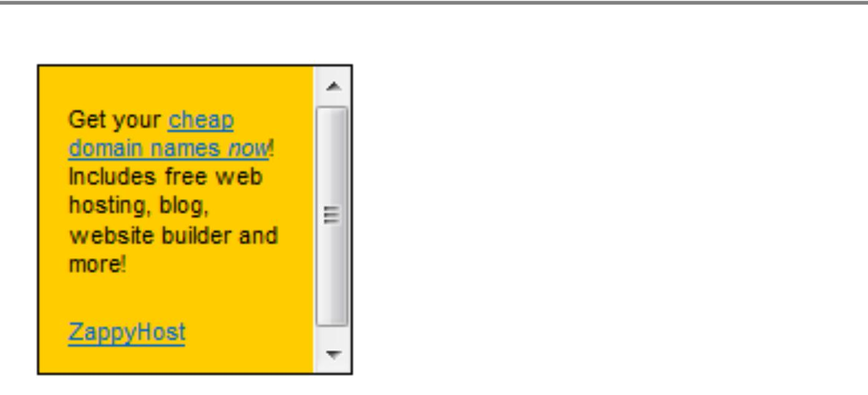

36

